Name: Hovan Hodges
Course: CST-305
Assignment Name: Project 3 - Green's Function and ODE with IVP
Date: 5/24/2026

Responsibilities and completed tasks by each team member
I completed all tasks as I worked on this by myself.
Specific problem solved
Within the class held on 5/18/26, you assigned us the ODE as follows:
$$y^{″}+4y=f\left(x\right),y\left(0\right)=1,y^{'}\left(0\right)=-2,$$
Where the forcing function 𝑓 is piecewise defined:
$$f\left(x\right)=\left\{\begin{aligned}0, x<0 \\ \sin{2x}, 0≤x≤2π \\ 0, x>2π.\end{aligned}\right.$$
The mathematical approach for solving it
Because the ODE you assigned us was already solved, below is the mathematical solution:
sin2t is replaced by the forcing function 𝑓(t):
$$y\left(x\right)=\cos{2x}-\sin{2x}+\frac{1}{2}\int_{0}^{x}{\sin{2\left(x-t\right)}f\left(t\right)dt}.$$
Since 𝑓(x) is piecewise defined on three intervals, we have to consider the evaluation of the definite integral accordingly:
(i) $x<0$
$$y_{p}\left(x\right)=\frac{1}{2}\int_{0}^{x}{\sin{2\left(x-t\right)}0dt=0}.$$
(ii) $0≤x≤2π$
$$y_{p}\left(x\right)=\frac{1}{2}\int_{0}^{x}{\sin{2\left(x-t\right)}\sin{2t}dt}$$
$$y_{p}\left(x\right)=\frac{1}{8}\sin{2x}-\frac{1}{4}x\cos{2x}.$$
(iii) $x>2π$
$$y_{p}\left(x\right)=\frac{1}{2}\int_{0}^{2π}{\sin{2\left(x-t\right)}\sin{2t}dt}+\frac{1}{2}\int_{2π}^{x}{\sin{2\left(x-t\right)}0dt}$$
$$y_{p}\left(x\right)=\frac{1}{2}\int_{0}^{2π}{\sin{2\left(x-t\right)}\sin{2t}dt}$$
$$y_{p}\left(x\right)=\frac{1}{4}{\left[-\frac{1}{4}\sin\left(2x-4t\right)-t\cos{2x}\right]}_{0}^{2π}$$
$$y_{p}\left(x\right)=-\frac{1}{16}\sin{(2x-8π)}-\frac{1}{2}π\cos{2x}+\frac{1}{16}\sin{2x}$$
$$y_{p}\left(x\right)=-\frac{1}{2}π\cos{2x}.$$
Consequently, $y_{p}\left(x\right)$ is
$$y_{p}\left(x\right)=\left\{\begin{aligned}0, x<0 \\ \frac{1}{8}\sin{2x}-\frac{1}{4}x\cos{2x}, 0≤x≤2π \\ -\frac{1}{2}π\cos{2x}, x>2π.\end{aligned}\right.$$
With the complete solution being:
$$y_{p}\left(x\right)=y_{h}\left(x\right)+y_{p}\left(x\right)=\left\{\begin{aligned}\cos{2x}-\sin{2x}, x<0 \\ (1-\frac{1}{4}x)\cos{2x}-\frac{7}{8}\sin{2x}, 0≤x≤2π \\ (1-\frac{1}{2}π)\cos{2x}-\sin{2x}, x>2π.\end{aligned}\right.$$
The approach for implementation in code
The implementation of the data propagation model relies on numerical integration and visualization libraries within the Python ecosystem. To compute the network's response to data ingestion, the code defines the Green's function for an underdamped spatial oscillator and applies SciPy's quad function to continuously integrate the product of this Green's function and the piecewise forcing function across the network nodes. By discretizing the network topology into an array of positional nodes using NumPy, the script iteratively calculates the accumulated data buffer at each sequential hop. Finally, Matplotlib is utilized to visualize the initial data burst signal with the resulting wave of node congestion, providing a clear visual representation of how latency and load-balancing parameters dictate the propagation dynamics.
Screenshots depicting key phases in the program execution
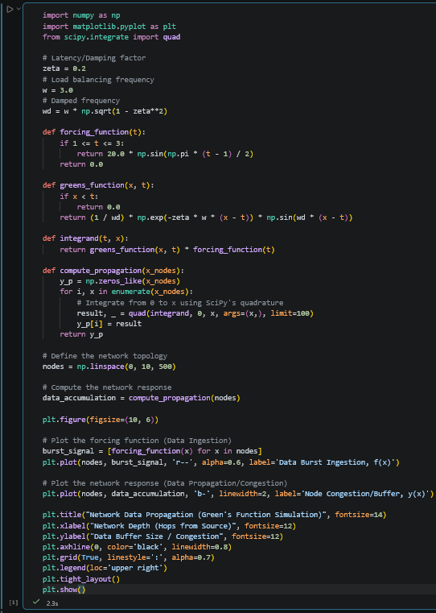
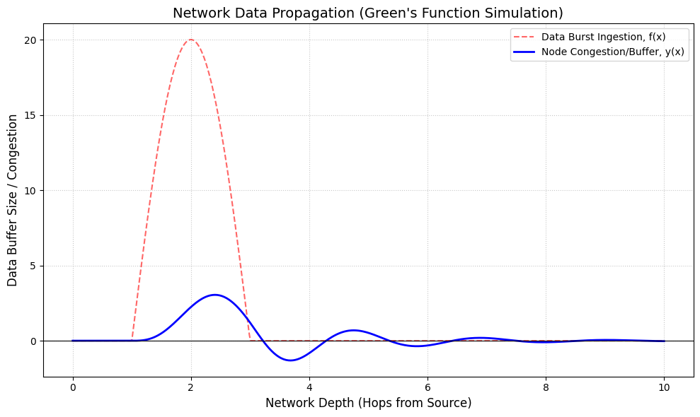
References for theory and code sources
- Google’s Gemini
- Greens Function: Example 6
- Instructor Kiju Kim’s presentation slides
README document written in Markdown, detailing how to install and run the program
The README.md document is posted within the Github and was uploaded alongside this PDF document inside Halo Learn.

